Report

# Brainstorming and empathy map.

* 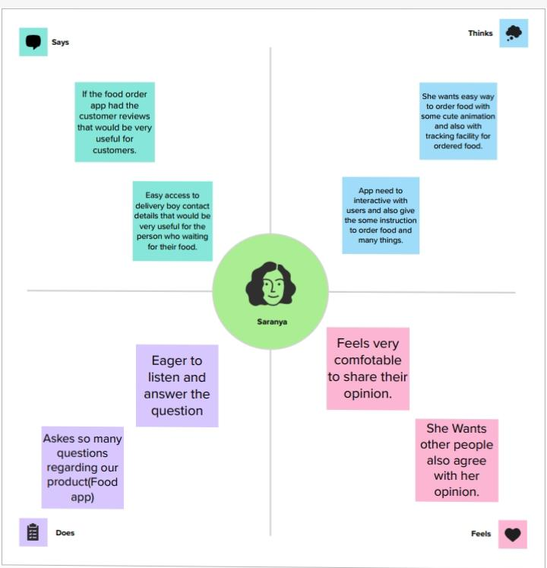Brainstorming and the empathy map are very use full to our higher education..
* It’s also help to know about many things which we haven’t yet seen.
* It’s is useful to us.
* Through this we gain knowledge. 